How do I sign in to Classroom?

Ready to sign in?
You must have an active internet connection to sign in. If you already know how to sign in to Classroom, go to classroom.google.com. Or, follow the detailed steps below.
Computer AndroidiPhone & iPad

Sign in for the first time
- Go to classroom.google.com and click Go to Classroom.
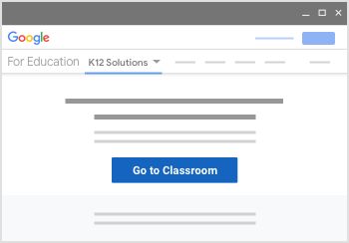
- Enter the email address for your Classroom account and click Next.
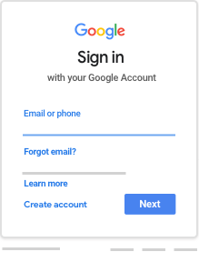
- Enter your password and click Next.
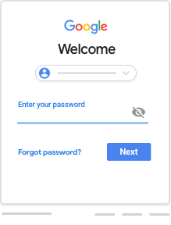
- If there is a welcome message, review it and click Accept.
- If you're using a G Suite for Education account, click I’m A Student or I’m A Teacher.
Note: Users with personal Google Accounts won’t see this option.
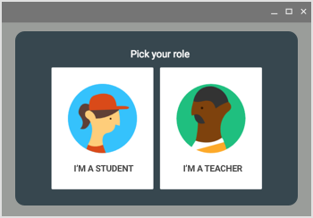
- Click Get Started.
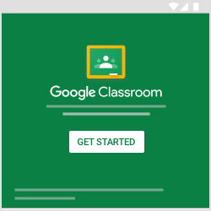

Switch to a different account
If you’re signed in to multiple accounts and need to switch to the account that you use with Classroom:
- At the top, click your profile image or initial.
- Select the account.

