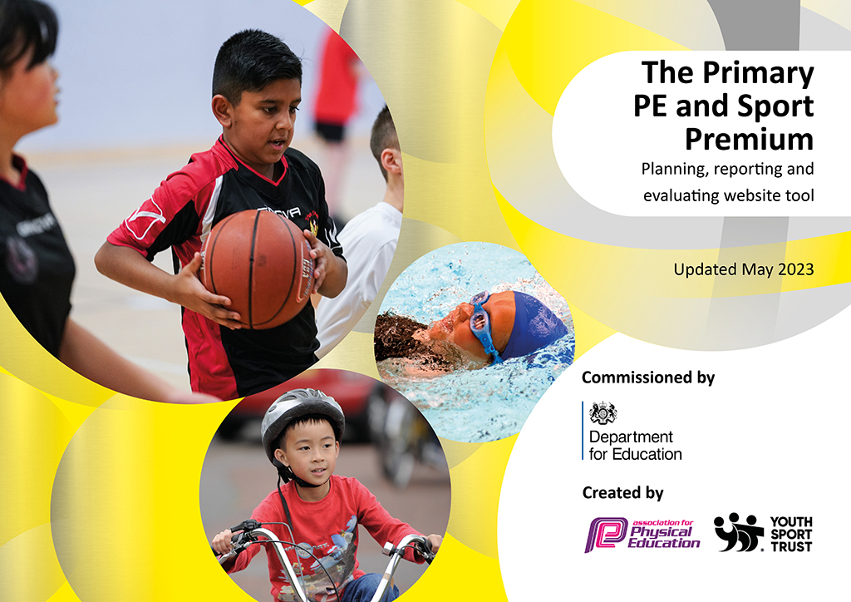
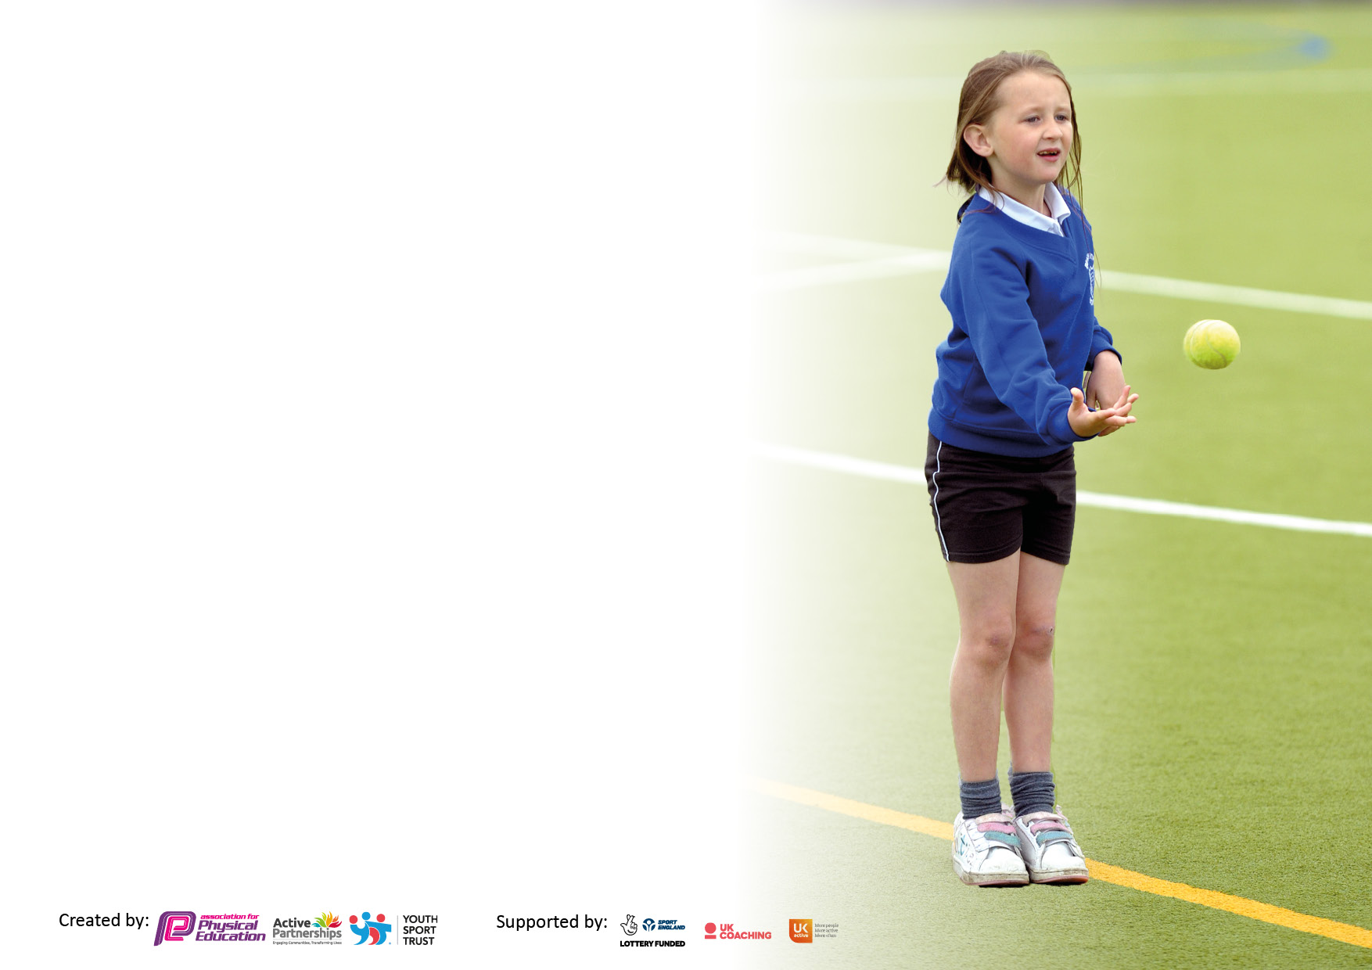

It is important that your grant is used effectively and based on school need. The Education Inspection Framework makes clear there will be a focus on ‘whether leaders and those responsible for governors all understand their respective roles and perform these in a way that enhances the effectiveness of the school’.

Under the Quality of Education judgement, Ofsted inspectors consider:
Intent - Curriculum design, coverage and appropriateness
Implementation - Curriculum delivery, teaching (pedagogy) and assessment
Impact - Attainment and progress

To assist schools with common transferable language, this template has been developed to utilise the same three headings which should make your plans easily transferable between working documents.

Schools must use the funding to make additional and sustainable improvements to the quality of Physical Education, School Sport and Physical Activity (PESSPA) they offer. This means that you should use the Primary PE and sport premium to:

- Develop or add to the PESSPA activities that your school already offers
- Build capacity and capability within the school to ensure that improvements made now will benefit pupils joining the school in future years
- The Primary PE and sport premium should not be used to fund capital spend projects; the school’s budget should fund these.

Please visit https://www.gov.uk/guidance/pe-and-sport-premium-for-primary-schools for the revised DfE guidance, including the 5 key indicators across which schools should demonstrate an improvement. This document will help you to review your provision and to report your spend. DfE encourages schools to use this template as an effective way of meeting the reporting requirements of the Primary PE and Sport Premium.

We recommend you start by reflecting on the impact of current provision and reviewing the previous spend.

Schools are required to publish details of how they spend this funding, including any underspend from 2021/2022, as well as on the impact it has on pupils’ PE and sport participation and attainment.

We recommend regularly updating the table and publishing it on your website throughout the year. This evidences your ongoing self-evaluation of how you are using the funding to secure maximum, sustainable impact. Final copy must be posted on your website by the end of the academic year and no later than the 31 July 2023.

Details with regard to funding
Please complete the table below.

Total amount carried over from 2021/22 | £0
Total amount allocated for 2022/23 | £19,470
How much (if any) do you intend to carry over from this total fund into 2023/24? | £1,100
Total amount allocated for 2022/23 | £19,470
Total amount of funding for 2022/23 to be reported on by 31st July 2023 | £20,570
Swimming Data
Please report on your Swimming Data below.

Meeting national curriculum requirements for swimming and water safety.

N.B. Complete this section as best you can. For example, you might have practised safe self-rescue techniques on dry land which you can then transfer to the pool when school swimming restarts.
Due to exceptional circumstances priority should be given to ensuring that pupils can perform safe self-rescue even if they do not fully meet the first two requirements of the NC programme of study
What percentage of your current Year 6 cohort swim competently, confidently and proficiently over a distance of at least 25 metres?  N.B. Even though your pupils may swim in another year, please report on their attainment on leaving primary school at the end of the summer term 2023.  Please see note above | 52%
What percentage of your current Year 6 cohort use a range of strokes effectively [for example, front crawl, backstroke and breaststroke]?  Please see note above | 46%
What percentage of your current Year 6 cohort perform safe self-rescue in different water-based situations? | 93%
Schools can choose to use the Primary PE and sport premium to provide additional provision for swimming, but this must be for activity over and above the national curriculum requirements. Have you used it in this way? | No

Action Plan and Budget Tracking
Capture your intended annual spend against the 5 key indicators. Clarify the success criteria and evidence of impact that you intend to measure to evaluate for pupils today and for the future.

Academic Year: 2022/23 | Total fund allocated:19,470 | Date Updated: July 2023
Key indicator 1: Increase confidence, knowledge and skills of all staff in teaching PE and sport |  |  |  | Percentage of total allocation:
 |  |  |  | 26%
Intent | Implementation |  | Impact
Your school focus should be clear on what you want the pupils to know and be able to do. What do they need to learn and to consolidate through practice: | Make sure your actions to achieve are linked to your intentions: | Funding allocated: | Evidence of impact:  What do pupils now know and what can they now do? What has changed? | Sustainability and suggested next steps:
- Increase opportunities for  pupils to be physically active  outside of PE lessons.  - To build a curriculum that  enables children to develop  knowledge, skills and  vocabulary in a broad range of  sporting activities. Key words to be shared with the children.  - 2 x 45 min PE sessions a week.  - Children engaged in high  quality play/regular activity  throughout lunchtimes. | - Specific sports allocated at  lunchtimes with a coach and  adult supervision.  - Active theme day –  European School Sports day,  Show Racism the Red card.  - Daily mile initiative to  encourage 15 minutes  activity every day.  - Introduction of walk to  schools to encourage active  movement to get to school.  - Utilise active learning  strategies during indoor  lessons – BBC super movers  and Just Dance.  - Range of activities across PE  Lessons.  Wide range of sporting opportunities after school delivered by teaching staff. | £4750 Progressive sports.  £300 PE Passport.  External rugby club - free | - Children engage in  physically active play at  break and lunchtimes.  - Improved behavior  during active lunchtimes.  - Children engage in  competitive team games  at lunchtimes.  - Give children the  opportunity to move  during lessons to aid focus  on learning.  - Children engage in  physically active learning  within core and  foundation learning  within the classroom.  - Children recognize the benefit of participation in physical activity for their health and social skills.  Children understand there are a wide range of sports available for them to participate in. | - Continued monitoring  of PE lessons ensuring 2  45 minute sessions are  completed every week.  - Continued use of PE Passport to capture evidence and also for use of assessment.  - Encourage everyone to  be participating in the  Daily Mile daily.  - Continue to ensure staff  at lunchtimes are able  to promote physical  active play confidently.  - Encourage all staff to  Begin using Walk to School and  record methods of  travel to school each  day.  - Continued monitoring  and audit of PE  equipment to ensure all  equipment is available.
Key indicator 2: The engagement of all pupils in regular physical activity – Chief Medical Officers’ guidelines recommend that  primary school pupils undertake at least 30 minutes of physical activity a day in school |  |  |  | Percentage of total allocation:
 |  |  |  | 4%
Intent | Implementation |  | Impact
Your school focus should be clear on what you want the pupils to know and be able to do. What do they need to learn and to consolidate through practice: | Make sure your actions to achieve are linked to your intentions: | Funding allocated: | Evidence of impact:  What do pupils now know and what can they now do? What has changed? | Sustainability and suggested next steps:
- Use expertise of a coach to  continue develop and  improve behaviour in Sport  and PE.  - Continue to develop the  outdoor curriculum –  promoting outdoor  Adventurous Activities and  outdoor learning.  - Build whole school  relationships with MCFC  coaches in CPD sessions and  enhancement programmes.  - Build relationships with local  rugby league club Salford Red  Devils. – Opportunities for  visits and free tickets.  - FSM and SEND children are planned for and lessons and clubs facilitate full engagement of all children  • Improved use of the Forest School area to support the Curriculum and children’s mental health and wellbeing | Targeted groups to work with coaches on team skills, resilience and positive behaviours.  • KS2 lunchtime sport organised to improve fair play, sportsmanship and positive behaviours through sports and activity.  • Freddie Fit sessions for whole school to inspire and motivate staff and children.  • Continue to promote Daily Mile as a regular part of the school week.  • Timetables gives classes sessions with coaches and access to indoor and outdoor facilities.  - Conversations with children during PSHE around how being physically active can improve wellbeing and resilience.  • Use forest school area and the equipment in forest school to support children’s mental health and wellbeing.  • Development of school garden to grow fresh fruit and vegetables. | £798 Freddie Fit | - Children engaged in lunchtime sessions.  - Children thoroughly enjoy PE sessions with teachers and coaches.  • Children recognise the benefit of participation in physical activity for their health and social skills.  • Children understand the importance of rules, self-discipline when engaging in PESSPA, which transfers to other areas of learning.  • Children recognise the value of PESSPA to help aid concertation.  - Children have two half terms of forest school throughout the year with a qualified lead.  • Grow and maintain local fruit and vegetables. | • Promote awareness of personal challenge in all year groups.  • Continued monitoring of forest school sessions and audit of equipment.  • Continued monitoring of lunchtimes.  • Continue to use MCFC for their life workshops.  • Look into more opportunities with Salford Red Devils.  • Feedback from children on forest school and PE sessions.  • Continue to maintain school garden.

Key indicator 3: The profile of PE and sport is raised across the school as a tool for whole school improvement |  |  |  | Percentage of total allocation:
 |  |  |  | 40%
Intent | Implementation |  | Impact
Your school focus should be clear on what you want the pupils to know and be able to do. What do they need to learn and to consolidate through practice: | Make sure your actions to achieve are linked to your intentions: | Funding allocated: | Evidence of impact:  What do pupils now know and what can they now do? What has  changed? | Sustainability and suggested next steps:
- Promote active sessions at lunchtimes.  - Support reception in preparing children for PE in KS1.  - Support EYFS in being more active outside.  - NQT staff have support in place to deliver high quality PE lessons.  - • Continued focus on developing staff across the year in the teaching of PE. | - Lunchtime coaches model active sessions alongside lunchtime organisers to skills can be shared.  - Reception children to participate in OAA team, problem solving and leadership skills through outdoor learning curriculum.  - BS to attend PE SL courses.  - External clubs to deliver sessions to encourage participation. | £7000  City in the  Community CPD  Programme  £750  EYFS City in the  Community CPD | - Children have access to a variety of active sessions throughout lunchtimes.  - Children are supported in activities by competent and confident leaders.  - Teachers can confidently plan and deliver appropriate PE lessons utilising PE passport and knowledge gained in CPD.  - PE lessons build on skills in a progressive way.  - Subject leader is aware of the new Ofsted framework and its links to PE.  - Progression maps and key vocabulary shared with staff to develop improvement in PE. | - Ensure whole school are using PE passport to assess children and identify more able and less active.  - Staff voices to continue to support area of support as applicable.  - Audit and maintain PE equipment to ensure high quality PE lessons can be achieved.  - Look into Gym CPD for staff.  - Team teaching support for staff.
Key indicator 4: Broader experience of a range of sports and physical activities offered to all pupils |  |  |  | Percentage of total allocation:
 |  |  |  | 23%
Intent | Implementation |  | Impact
Your school focus should be clear on what you want the pupils to know and be able to do. What do they need to learn and to consolidate through practice: | Make sure your actions to achieve are linked to your intentions: | Funding allocated: | Evidence of impact:  What do pupils now know and what can they now do? What has  changed? | Sustainability and suggested next steps:
• Continue to improve the skills and links of the PE subject leaders to impact on opportunities for children.  • Continue to increase opportunities for children in the local community.  • Forest school outdoor teacher maintained.  - Extracurricular activities on offer for children who would not normally attend clubs (netballs, rounders, football and Golf) | - Continue to keep an audit of resources.  - Ensure link is continued with Manchester Active – competitions.  - Ensure links with professional sports clubs (Salford and Manchester City) are maintained and opportunities are available to all children.  - Enter intra competitions.  - Lunchtime sports continue to be developed to offer a range of sports and activities.  - Football club established for KS2 children who do not attend football training. | £5349 – Sports equipment  £395 – Dance carnival workshop. | - Children have access to appropriate resources to engage in sport and activity.  - Opportunities gained to enter off school site events.  - Feedback with other local teachers around the work Manchester City do and how effective this is.  - Football tournaments have been attended for children in KS2.  - Local school link with other schools to arrange fixtures in the future.  - Children enjoyed football sessions after school. To be continued in September. | - Re-establish sports leaders to ensure experiences can be shared.  - Support ECT staff in delivering high quality PE.  - Increase and further develop links with other local schools.  - Variety of after school sports on offer to a range of age groups.

Key indicator 5: Increased participation in competitive sport |  |  |  | Percentage of total allocation:
 |  |  |  | 6%
Intent | Implementation |  | Impact
Your school focus should be clear on what you want the pupils to know and be able to do. What do they need to learn and to consolidate through practice: | Make sure your actions to achieve are linked to your intentions: | Funding allocated: | Evidence of impact:  What do pupils now know and what can they now do? What has  changed? | Sustainability and suggested next steps:
- Continue to focus on team games and sportsmanship in PE lessons and lunch times.  - Continue to focus on engaging PE lessons that engage all children in order to develop their skills.  - To attend local sports competitions to work alongside and compete against other local schools.  - Begin to offer more opportunities for intra school competitions with local schools. | - Lunchtime coach session timetabled for children in KS2.  - Promote school values in PESSPA sessions and focus on the benefits in sport for building resilience and positive wellbeing.  - PE lead to take children to competitions.  - Manchester PE association membership – school games competitions where possible.  - Identify how to ‘be a good sport’ by shaking hands and looking after equipment.  - Promote team games and attendance in competitive sports events. | £683.15 Sports kits  £495.00 transport to competitions | - Increased enthusiasm for PE and sport across whole school.  • High participation in lunchtime sport sessions.  • Pupils thoroughly enjoy PE and Sport based on pupil voice.  • Children have increased confidence, team skills, resilience and fair play  - Children are very willing to represent the school in sporting events – where possible. | - Staff to offer more sporting opportunities after school?  - Continue to promote an awareness of intra school competitions.  - Continue to build on team building, problem solving and leadership in PE lessons.  - Continue to enter intra school competitions and begin to introduce new sports such as golf.  - Children to continue to demonstrate positive behaviours in all sports/PE.

Signed off by
Head Teacher:
Date:
Subject Leader: | Ben Sunderland
Date: | 14/07/2023
Governor:
Date:

